River Tosca
The intimate River Tosca sails the Nile River in luxury and style. The ship provides a relaxing and comfortable setting for guests as they cruise the legendary Nile River and explore its most wondrous cultural sites. The vessel features a stylishly adorned lounge with full-service bar, cozy library, restaurant, fitness room, massage room, and an expansive Sun Deck with shaded cabanas and a swimming pool, perfect for a refreshing dip.

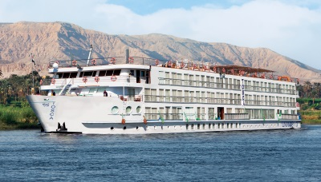
PreviousNext
Deck Plans

Detailed Information
  Ship Statistics
   | Year Built | 2009
   | Registry | Egypt
   | Length | 236 feet
   | Beam | 46 feet
   | Passenger Capacity | 82
   | Crew Size | 60
   | Total Inside Cabins | 0
   | Total Outside Cabins | 42
   | Cabins & Suites w/ verandas | 42
   | Suites | 42
   | Maximum Occupancy per room | 2
   | Age Restrictions | All must be 18-20 or one must be 21 or older
   | Dinner Seatings | 1
   | Seating Assignments | Open
   | Dining Hours | 7PM
   | Dining Room Dress Code | With the exception of Captain's night, dress is casual; jeans not permitted.
   | Tipping Expected? | Yes
   | Tipping Guidelines | Per person/day: Shipboard crew, $6. Tour manager, $4. Local guide, $2-$3. Driver, $1-$2. Total, $13-$15 per person/day.
   | Onboard Currency | European Union Euro
  Services & Amenities
  Bars/Lounges | 2
  Beauty Salon/Barber Shop | Yes
  Casino | No
  Chapel | No
  Disco/Dancing | No
  Elevators | No
  Hot Tub | No
  Cell Phone Service | Yes
  Internet Center | No
  Wireless Internet Access | Yes
  Note: Available in certain areas
  Laundromats (self service) | No
  Laundry/Dry Cleaning | Yes
  Library | Yes
  Movie Theatre | No
  Outdoor Movie Screen | No
  Onboard Weddings | No
  Shops | Yes
  Showroom | No
  Spa | No
  Video Arcade | No
  Fitness & Sports Facilities
  Basketball Court | No
  Fitness Center | Yes
  Golf Driving Net | No
  Golf Simulator | No
  Ice Skating Rink | No
  Jogging Track | No
  Mini-Golf Course | No
  Rock Climbing Wall | No
  Swimming Pool | No
  Tennis Court | No
  Water Slide | No
  Water Sports Platform | No
  Cabin Features & Amenities
  24-Hour Room Service | No
  Hair Dryer | Yes
  Safe | Yes
  Telephone | Yes
  Television | Yes
  Kids Facilities
  Babysitting | No
  Children's Playroom | No
  Kiddie Pool | No
  Supervised Youth Program | No
  Teen Center | No
  Water Playground/Splash Park | No
  Special Needs & Requests
  Adjoining Cabins  (private connecting doors) | No
  Kosher Meals | Yes
  Single Occupancy Cabins | No
  Single Share Program | No
  Wheelchair-Accessible Cabins | No

